L1/L2 - St. Michelle (SMWE) – SailPoint - Password Reset or Account Unlocking

KB0029612

17 views

**Subject Matter Expert:**

**Category:** Access

**Subcategory:** Unlock

**Configuration Item:** SMWE Generic Password Reset/Unlock Account

**Primary Assignment Group:** SN SMWE IT Service Desk

**Knowledge Status:** Published

# Abstract

Instructions for resetting or unlocking Active Directory accounts for SMWE users using SailPoint Identify Access Management (IAM) tool.

# Procedure

**Password Reset:** End user has forgotten their password or their password has expired and calls to have their password reset.

1. [Please reference **KB0029608 - L1 – St. Michelle (SMWE) – Jump Server Access**](https://altria.service-now.com/kb_view.do?sysparm_article=KB0029608)

[**(https://altria.service-now.com/kb_view.do?sysparm_article=KB0029608)** to ac](https://altria.service-now.com/kb_view.do?sysparm_article=KB0029608)cess SMWE Jump Server before attempting to access the site.

1. Log into SailPoint. Select the 3 bars in the upper left corner and click on **Password Reset** under **SMWE**

[**- Manage Accounts**. https://iamportal.stemichelle.ustis.com:8443/identityiq/home.jsf](https://iamportal.stemichelle.ustis.com:8443/identityiq/home.jsf)

[(https://iamportal.stemichelle.ustis.com:8443/identityiq/home.jsf)](https://iamportal.stemichelle.ustis.com:8443/identityiq/home.jsf)

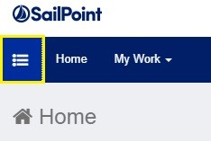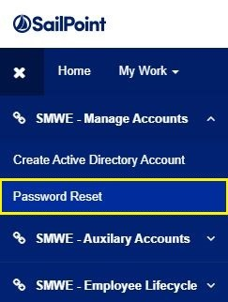

1. Select the identity of the user and click on **Reset Security Word/Date**.

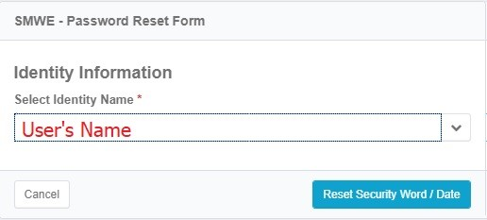

1. Input the answers provided by the user in respective questions and click on Authenticate and Reset

Password button.

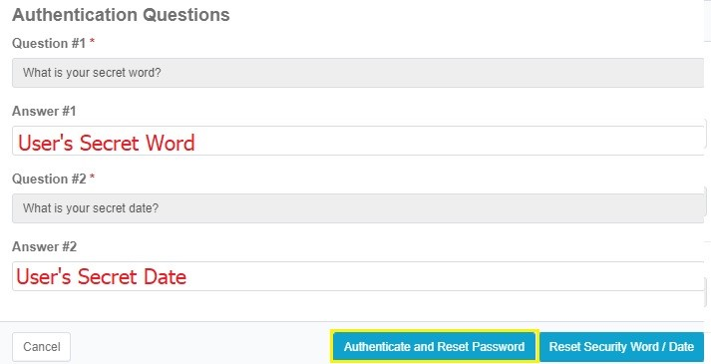

1. [If the user does not remember or has forgotten their Secret Word and/or Date, reference: **KB0029601 L1/L2 - St. Michelle (SMWE) – SailPoint – Secret Word and Date Reset (https://altria.servicenow.com/kb_view.do?sysparm_article=KB0029610)** and follow instructions to create a new Secret](https://altria.service-now.com/kb_view.do?sysparm_article=KB0029610) Word and Date which will be sent to their manager. The user will need to contact their manager then call back with a reference ticket number to have their account password reset.
2. The user’s new password will be displayed on the screen. The user will not be able to change this password for 24 hrs. After the 24 hr period, the user will be allowed to change their password using the normal process to change the password.

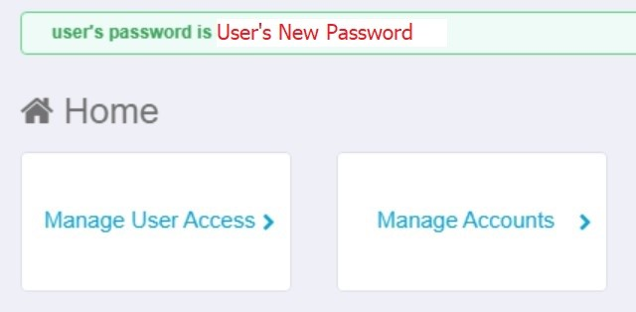

**Account Unlock:** End-users locked their account and need their account unlocked.

1. [Please reference **KB0029608 - L1 – St. Michelle (SMWE) – Jump Server Access**](https://altria.service-now.com/kb_view.do?sysparm_article=KB0029608)

[**(https://altria.service-now.com/kb_view.do?sysparm_article=KB0029608)** to ac](https://altria.service-now.com/kb_view.do?sysparm_article=KB0029608)cess SMWE Jump Server before attempting to access the site.

1. Log into SailPoint. Select the 3 bars in the upper left corner and click on **Manage Access** then **Manage**

[**Accounts**. https://iamportal.stemichelle.ustis.com:8443/identityiq/home.jsf (https://iamportal.stemichelle.ustis.com:8443/identityiq/home.jsf)](https://iamportal.stemichelle.ustis.com:8443/identityiq/home.jsf)

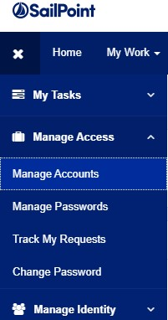

3. Enter the user’s name in the search field and hit enter to search.



1. Select **Accounts**.

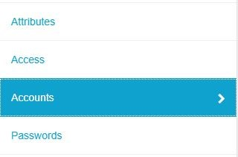

1. Select the 3 lines to the right of **Active Directory** and click on **Unlock**.

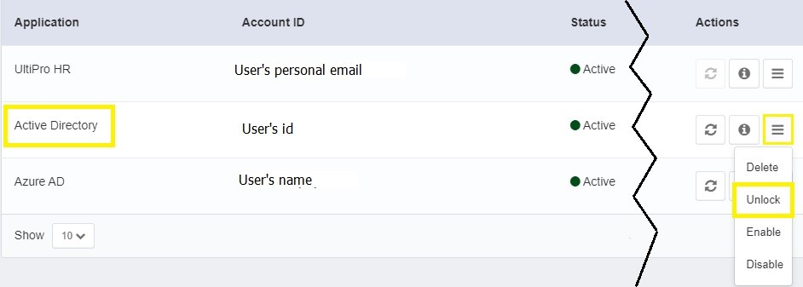

6. Click **Confirm**.



1. Click **Submit.**

